**D-Team 33 Milestone 1: Design Document**

Shawn Ge, Danica Fliss, Alex Fusco, Cole Thomson, Leah Witt

Course: CS 400 - Prof: Deb Deppeler

Due: 11/16/2018

**Class Summary:**

* Overall summary of classes needed for Food Planner Program.

|  |  |  |
| --- | --- | --- |
| **Class, Enum, or Interface** | **Type Name** | **Description of Use or Purpose** |
| Class | FilterGUI | Organizing GUI objects for filtering Foods and Meals |
| Class | FoodFile | Handles the importing of food information from a userFileName.txt into the into the initial food list and the exporting of food information from the current food list back to userFileName.txt |
| Class | DisplayPane | Shows certain information based on user input at center of GUI |
| Class | FoodPane | Displays food specific options and a list of current foods. (Left-hand pane in GUI) |
| Class | MealPane | Displays meal specific options and a list of current meals (Right-hand pane in GUI) |
| Class | Meal | Handles data related to a meal and methods for storing and manipulating meals. |
| Class | PopUpFood | Manages the pop-up window used to create a new food or upload a new list of foods |
| Class | PopUpMeal | Manages the pop-up window used to create a new meal |
| Class | Main | Runs the application |
| Interface | BPTreeADT | Defines how our BPTree class must be made. |
| Interface | FoodDataADT | Defines how our FoodData class must be made. |
| Class | BPTree | Organizes objects by given comparable keys, and also stores their given values. |
| Class | FoodData | List of FoodItem objects, but also organizes them, and can be used to search by certain filters. |
| Class | FoodItem | A FoodItem object stores information on one type of food. |

**Class Diagrams:**

* Classes that will help with building program with the desired functionality. Classes summarized by UML diagrams or tables.

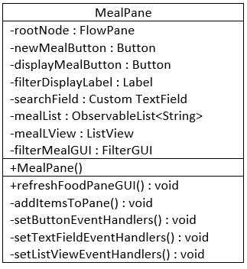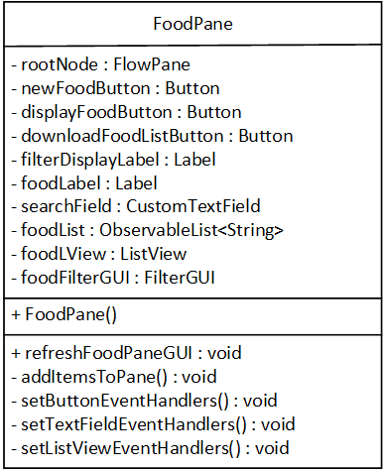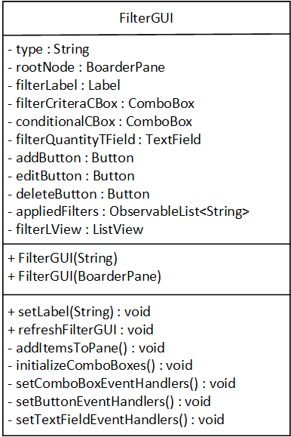

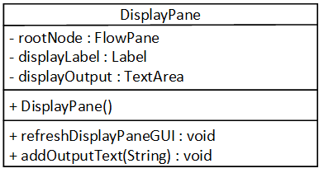

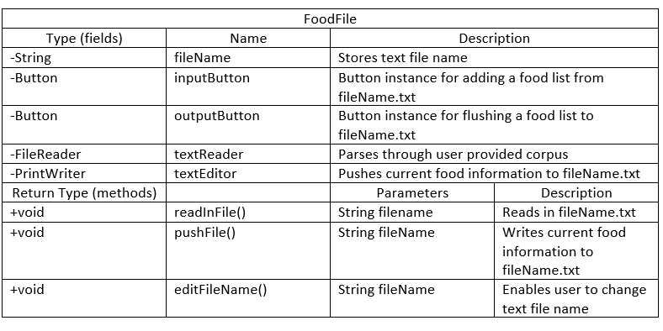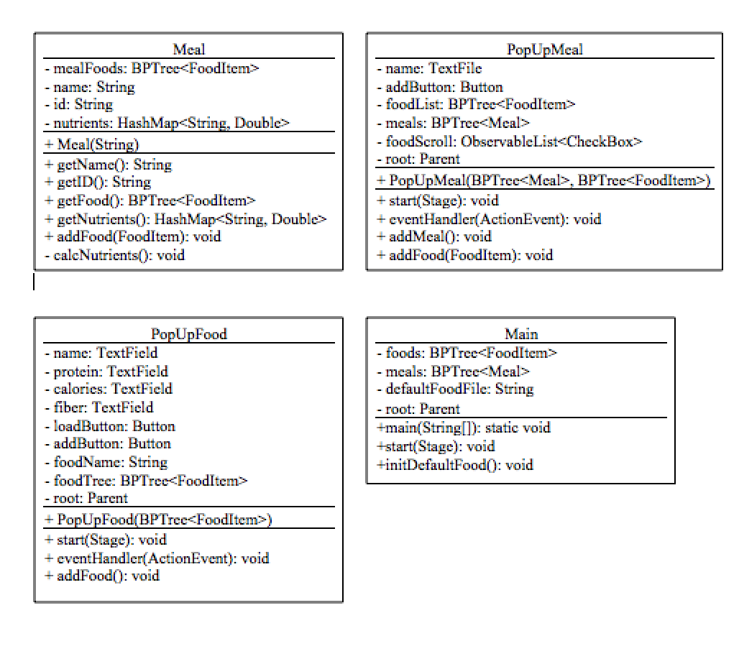

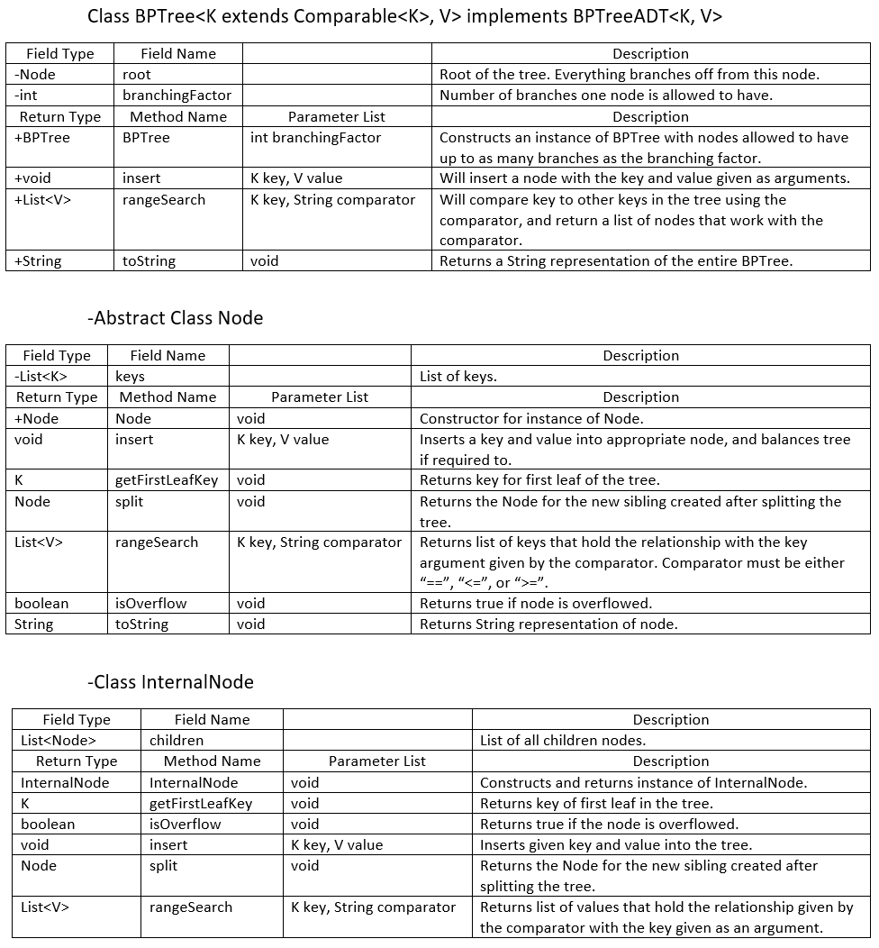

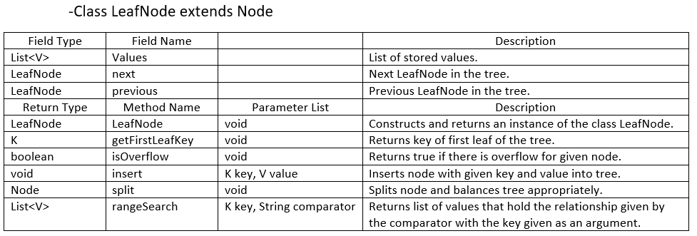

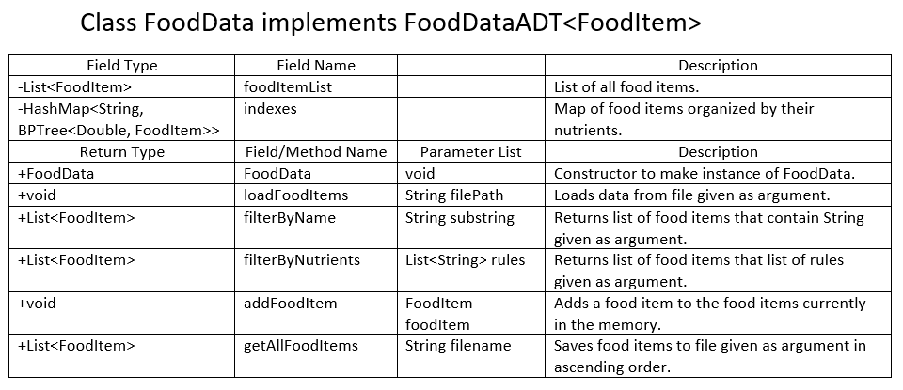

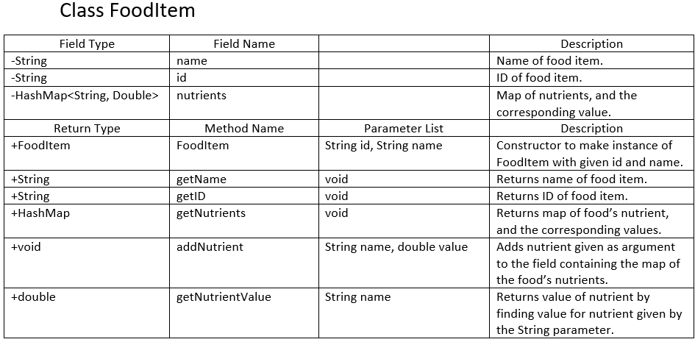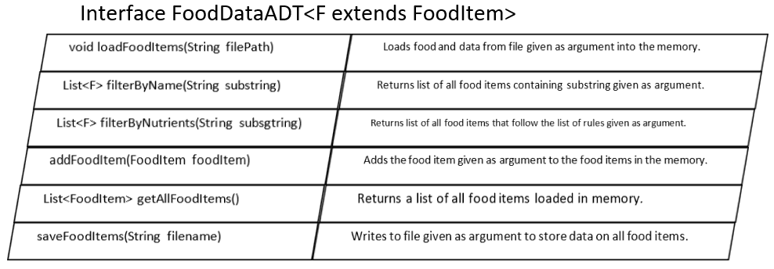

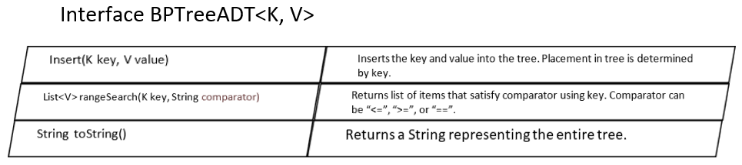

**Object Diagram:**

* Object instances that exist when program launches. These objects are responsible for GUI display, so back-end data structures are not shown.

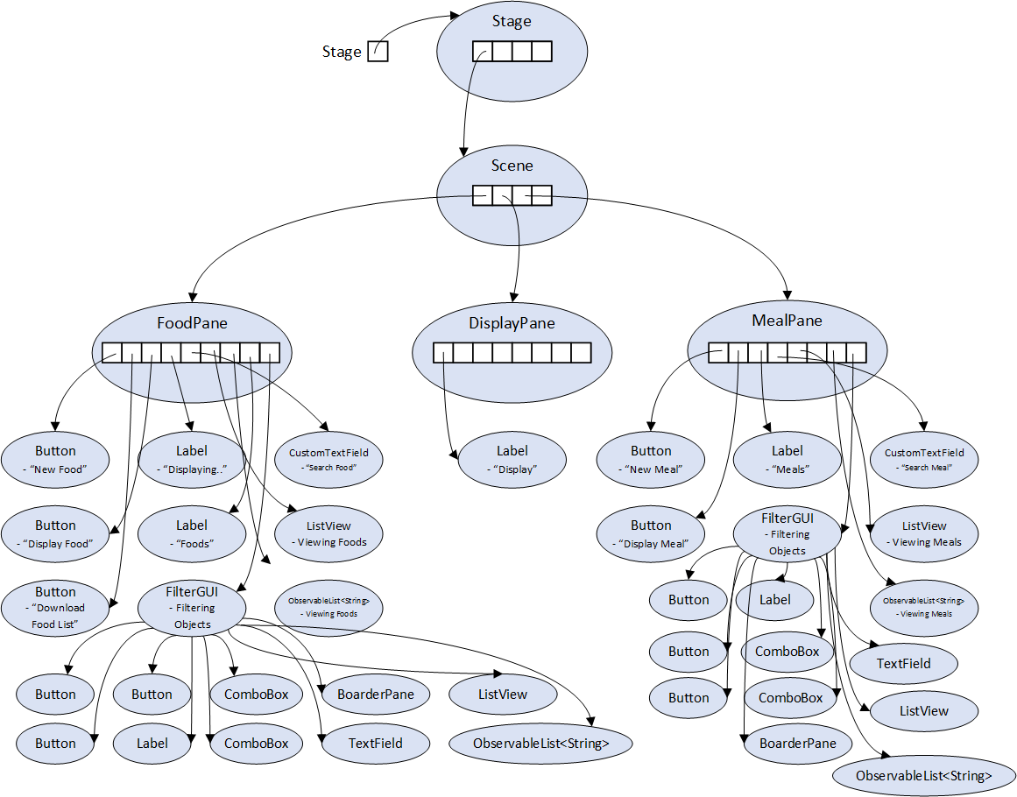

**GUI Layout Sketch:**

* Intended GUI at the start of the Food Planner Program.

